***AWS Assignments***

**Task: Write the steps to create an autoscaling group and associate the EC2 instances of that autoscaling group with an Application load balancer. When you click on the URL of Application load balancer, it should return the content from EC2 instances**.

Steps:

1. We have already created vpc and ec2 instance and have assigned them to required security groups.
2. We will go into ssh using putty key gen and putty.
3. After getting logged in(as done in assignment 2) type sudo su And check if httpd service is running or not.
4. If not then write commands: yum install httpd -y

service httpd start

chkconfig httpd on

cd /var/www/html

ls

if there is no file then create one using nano filename.html

1. Go to aws console and create a load balancer
2. Configure load balancer add listener,subnets(number of subnets you are going to select will give you that number of instances at start).
3. Select your security group.
4. While configure routing give name to your target group and under health checks in path write /filename.html
5. Then after registering your targets,review and create your load balancer.

Before creating autoscaling group upload a html file(index.html) in your bucket.

1. Following this,create an autoscaling group and click launch configuration.
2. Select an ami and click configure details.
3. Give required IAM role(eg.s3bucketaccess) and in advanced details under user data write the following bootstrap script

#!/bin/bash

yum install httpd -y

yum update -y

aws s3 cp s3://tsystems-bucket/filename.html /var/www/html/

service httpd start

chkconfig httpd on

1. Configure security group,review and click create launch configuration group.
2. Now you will come to autoscaling group and proceed with naming,assigning the group size and subnets acc. to requirements.
3. In advanced details select receive traffic from ELB and select the elb you have created and also see health check type.
4. Then configure your scaling policies,on selecting use scaling policies option

You can write your own conditions when do you need to increase the instances or decrease acc. to traffic.

1. Configure notifications,tags and review your auto scaling group.

Your auto scaling config group is successfully created and it will initiate the instances.We don’t need to ssh instances as we already wrote bootstrap script.

1. Now by clicking ip addresses of different instances,we can see that each ip address displays same thing as in that html file.
2. If we click on dns name of the load balancer it will also show us the same html page

We were successfully able to return the same contents from application load balancer as from ec2 instances.

**Task: Complete the bucket policy assignment. If in your S3 bucket you have some .png files and some .pdf files, create a bucket policy to make the .png files accessible to all public users (without login). And restrict the .pdf files to the public users.**

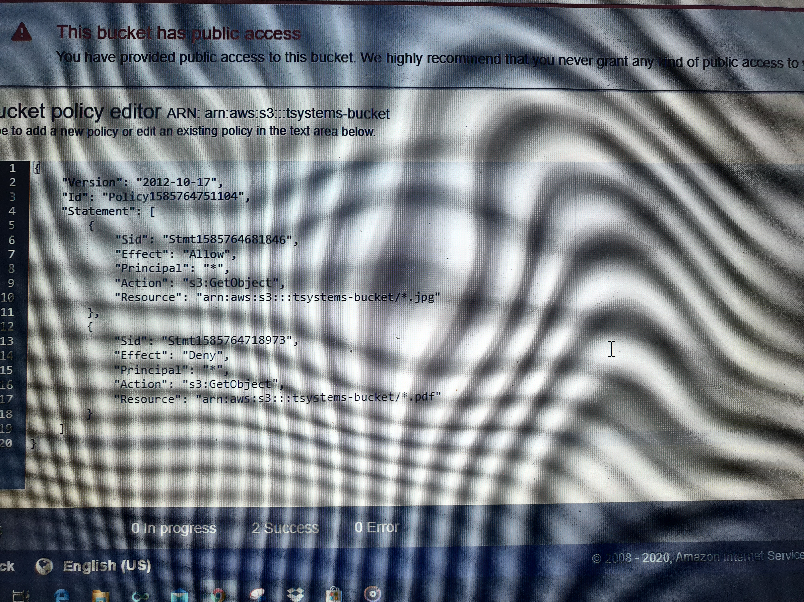

**Complete the Pycharm configurations with AWS toolkit with your account credentials.**

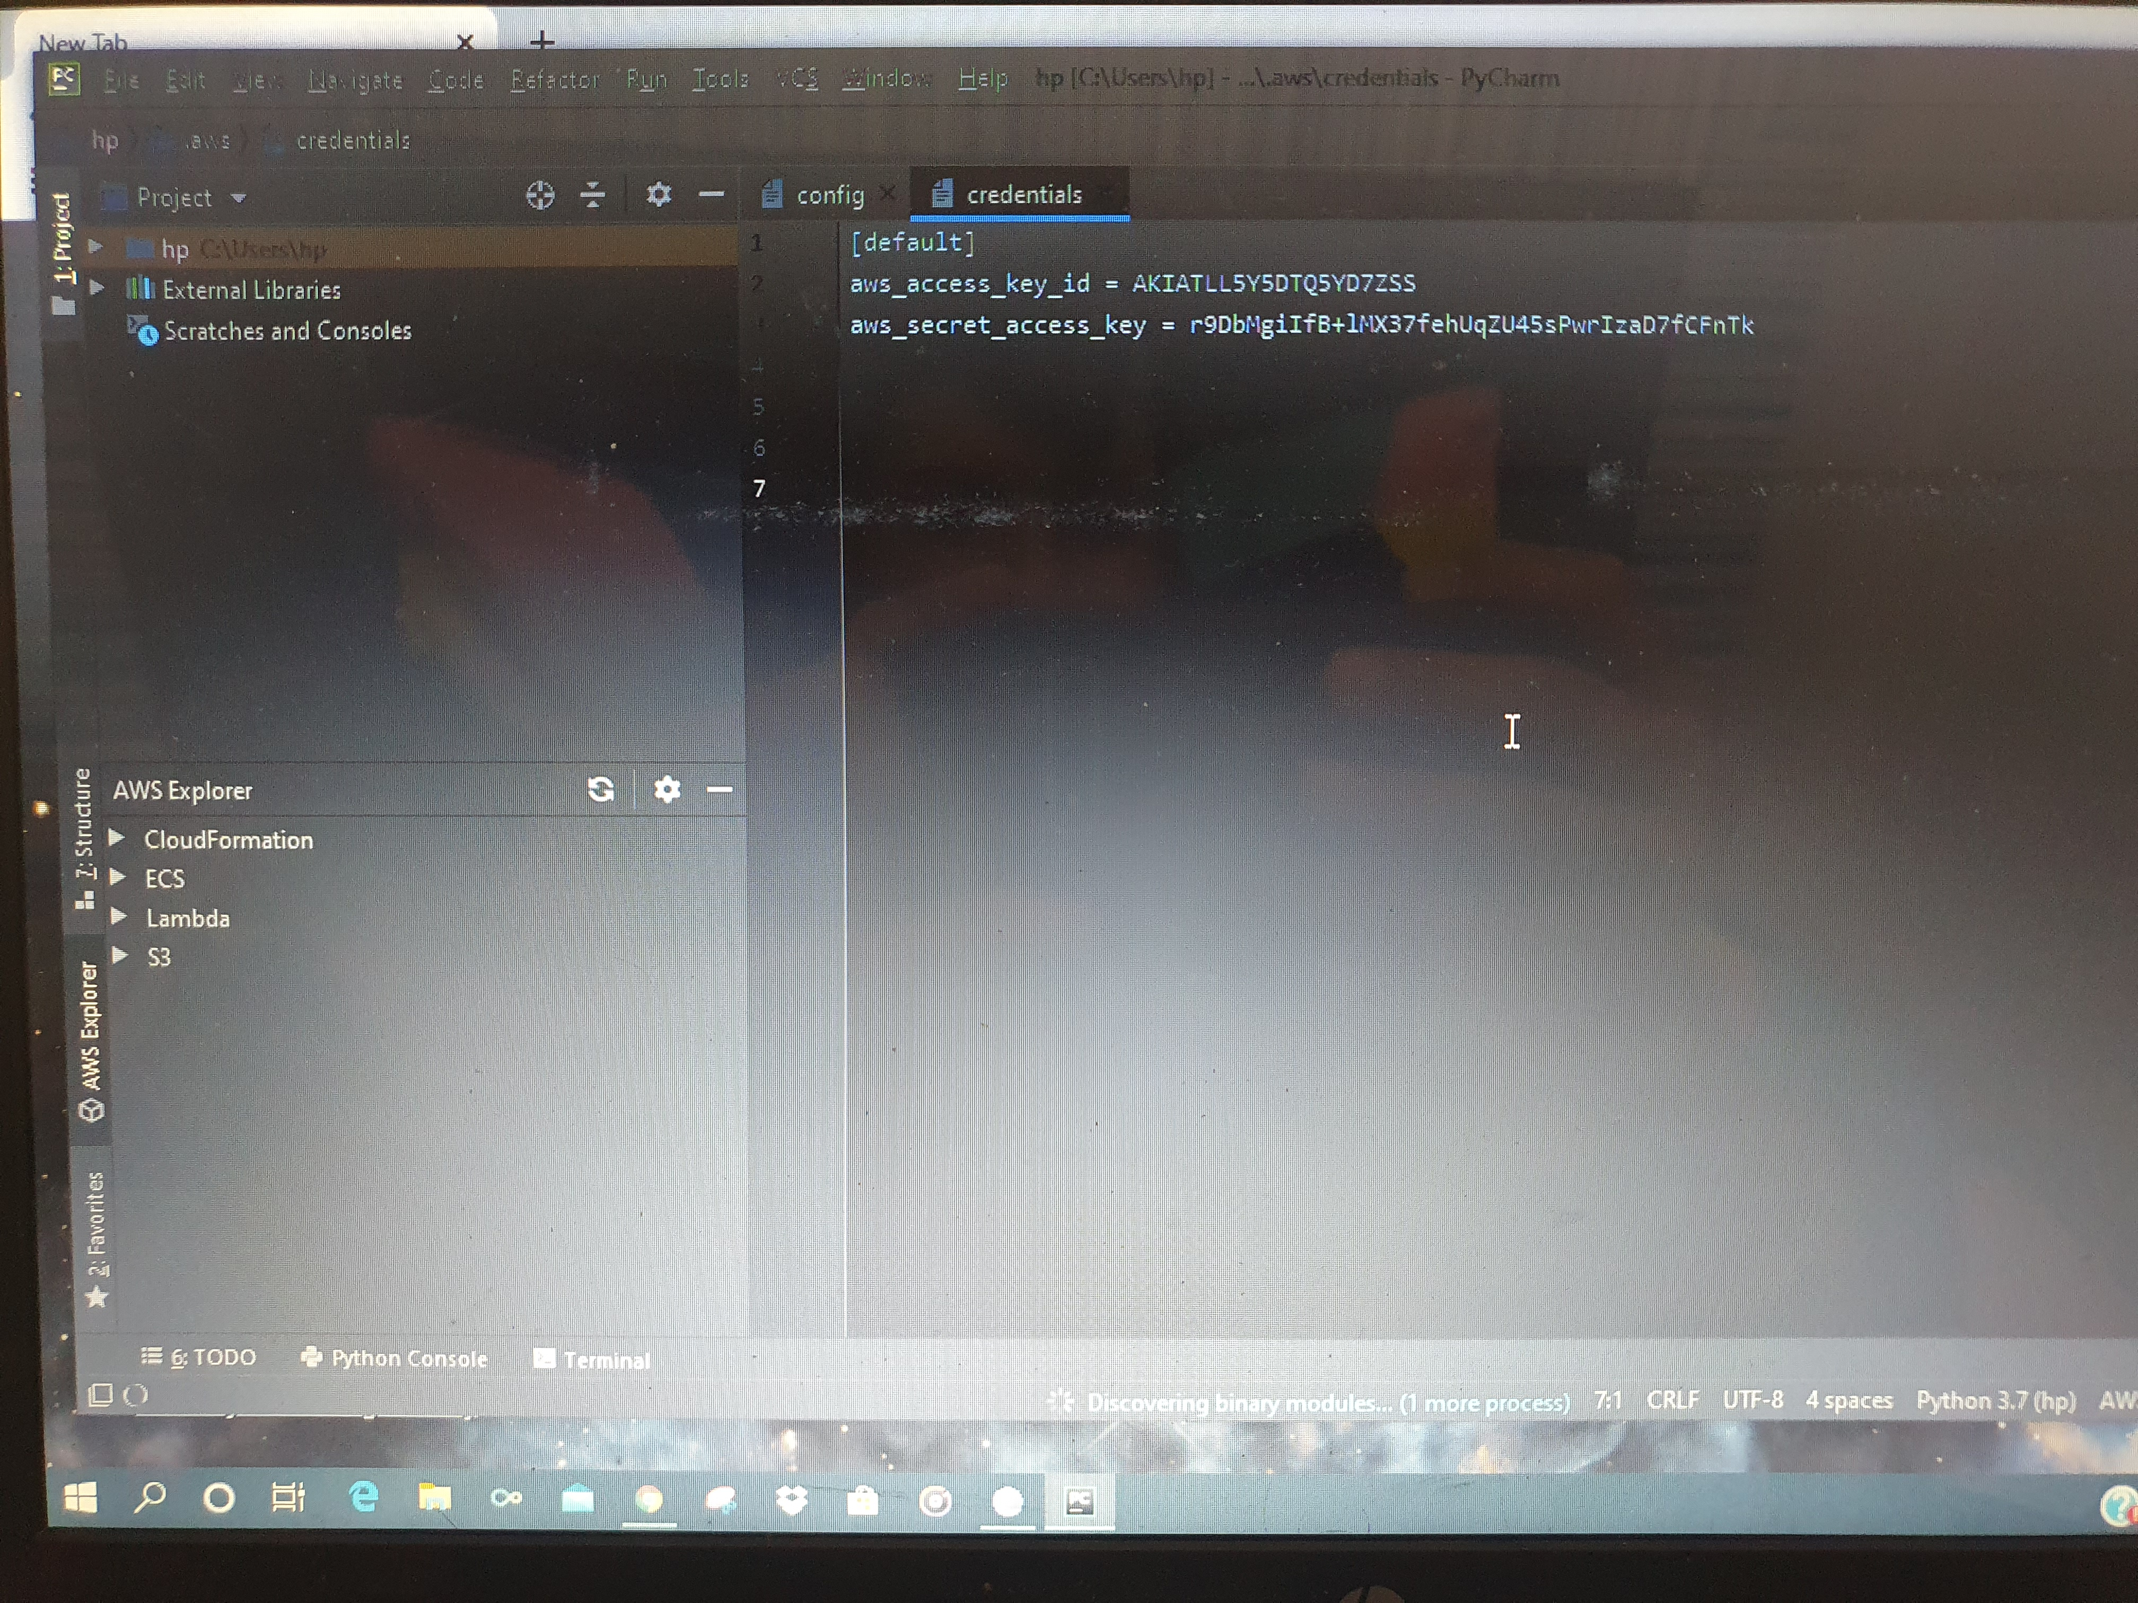

**TASK: Local setup**

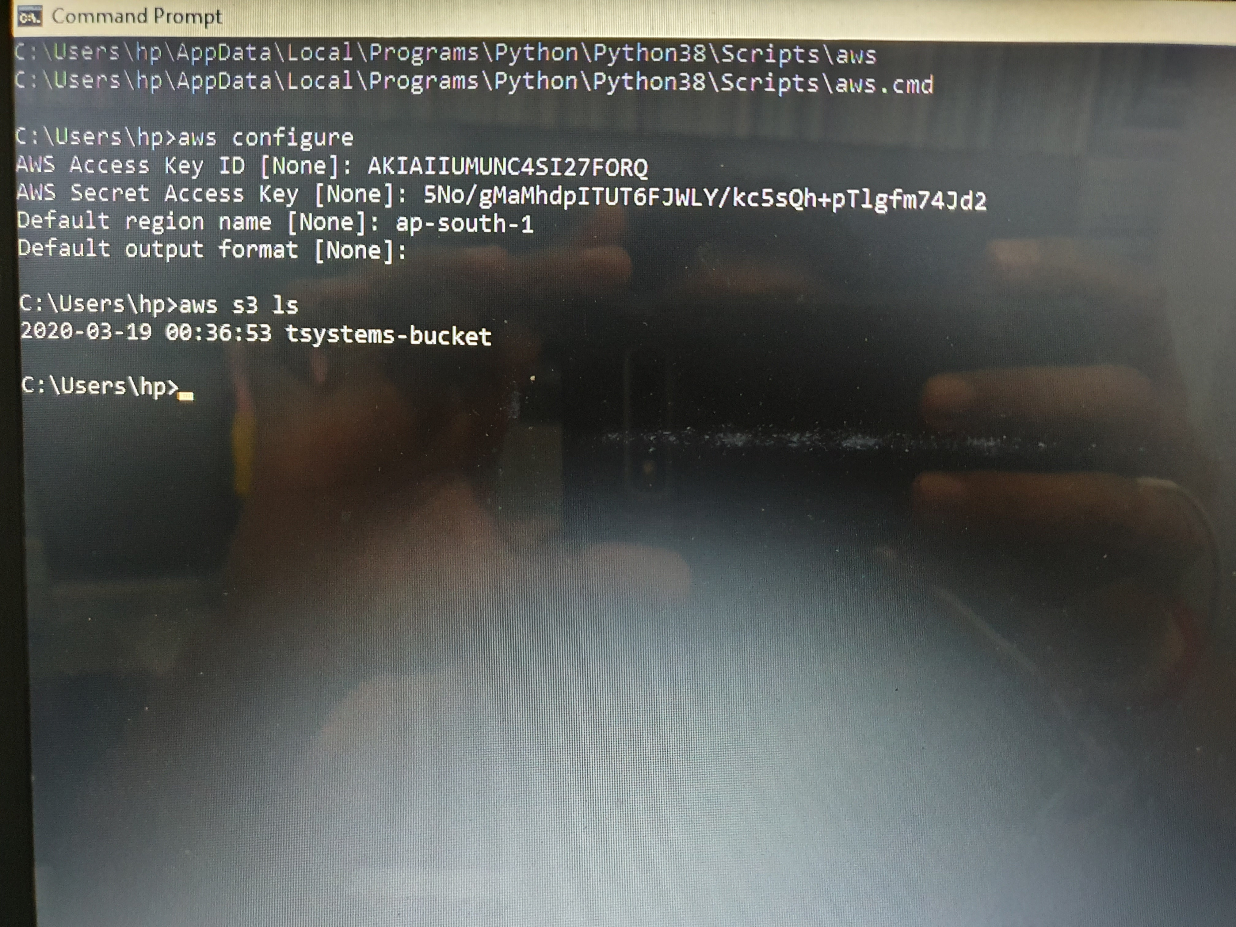

**TASKS-2nd April**

**1. Create a billing alarm on your account to check if your account billing exceeds $1 for the current month.**

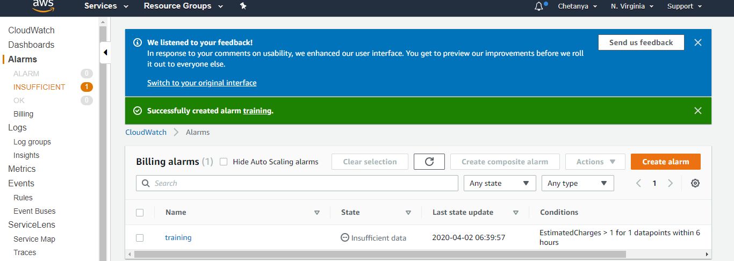

**2. Create an alarm on EC2 instance, to notify you if the instance is in stopped state or terminated state.** 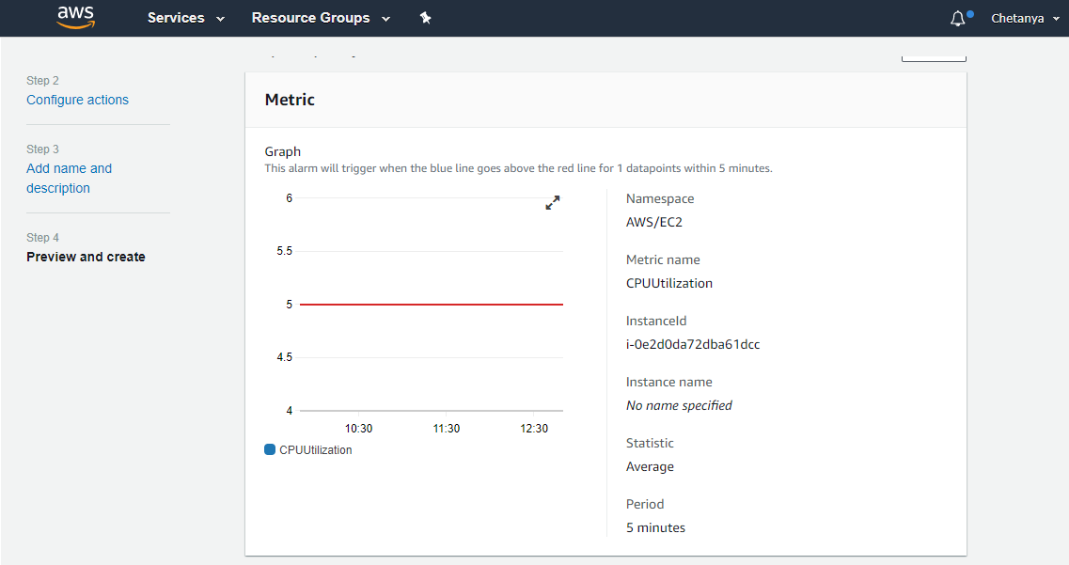

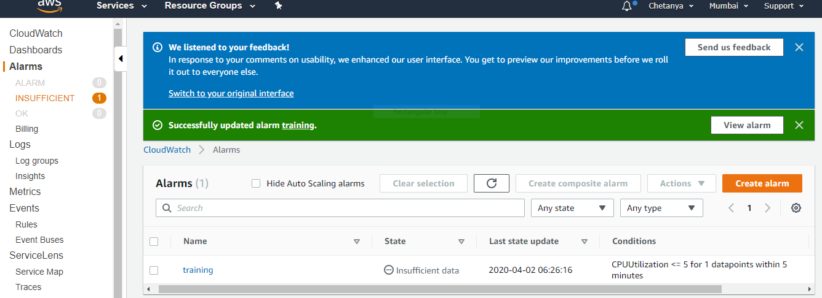

**3. Create a custom metric on EC2, to find memory utilization of a running EC2 instance.** 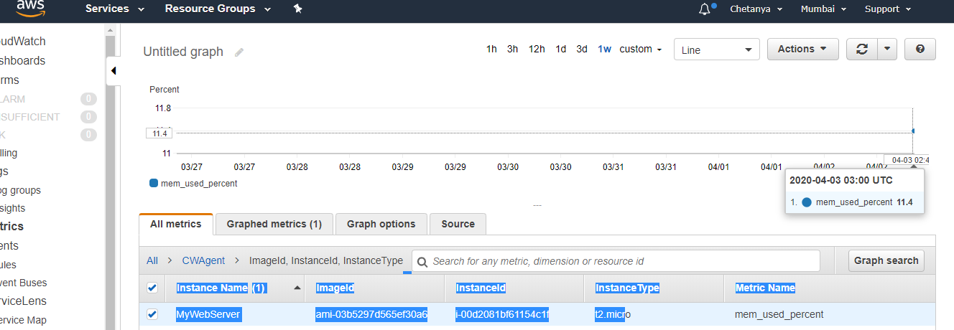

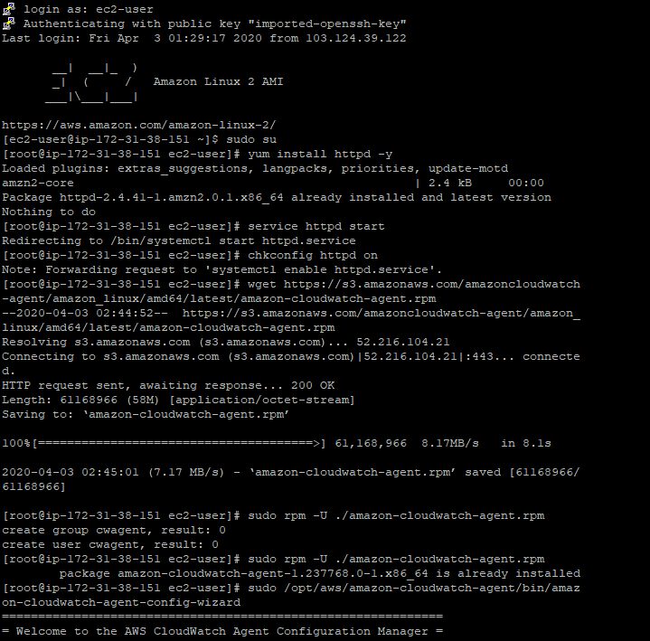

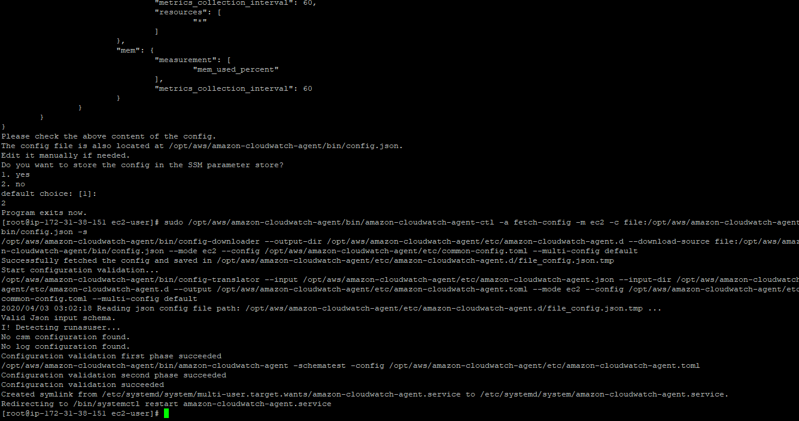

**Create a lambda function to start, stop and terminate a running EC2 instance. Also, verify the logs generated by the lambda in the Cloudwatch logs to check whether the lambda execution is done properly.**

**Code to stop:**

import boto3  
region = 'us-east-2'  
instances = ['i-0357d836c0c302bad']  
ec2 = boto3.client('ec2', region_name=region)  
  
def lambda_handler(event, context):  
    ec2.stop_instances(InstanceIds=instances)  
    print('stopped your instances: ' + str(instances))

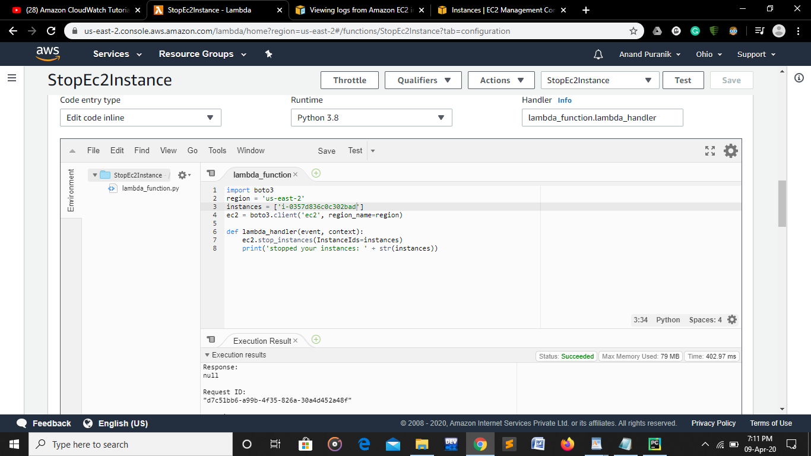

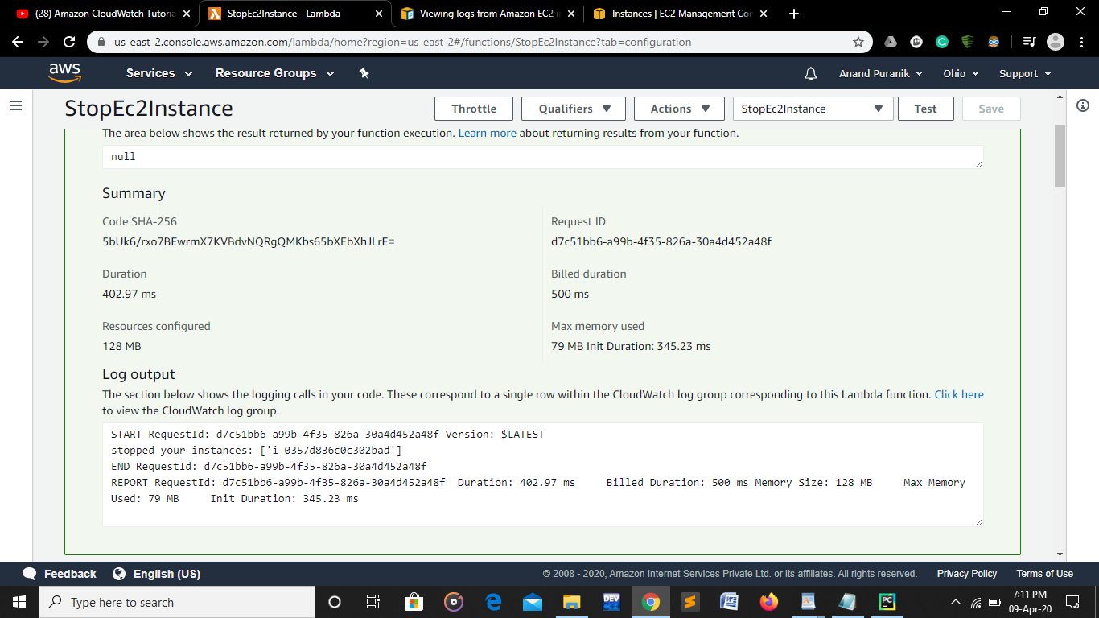

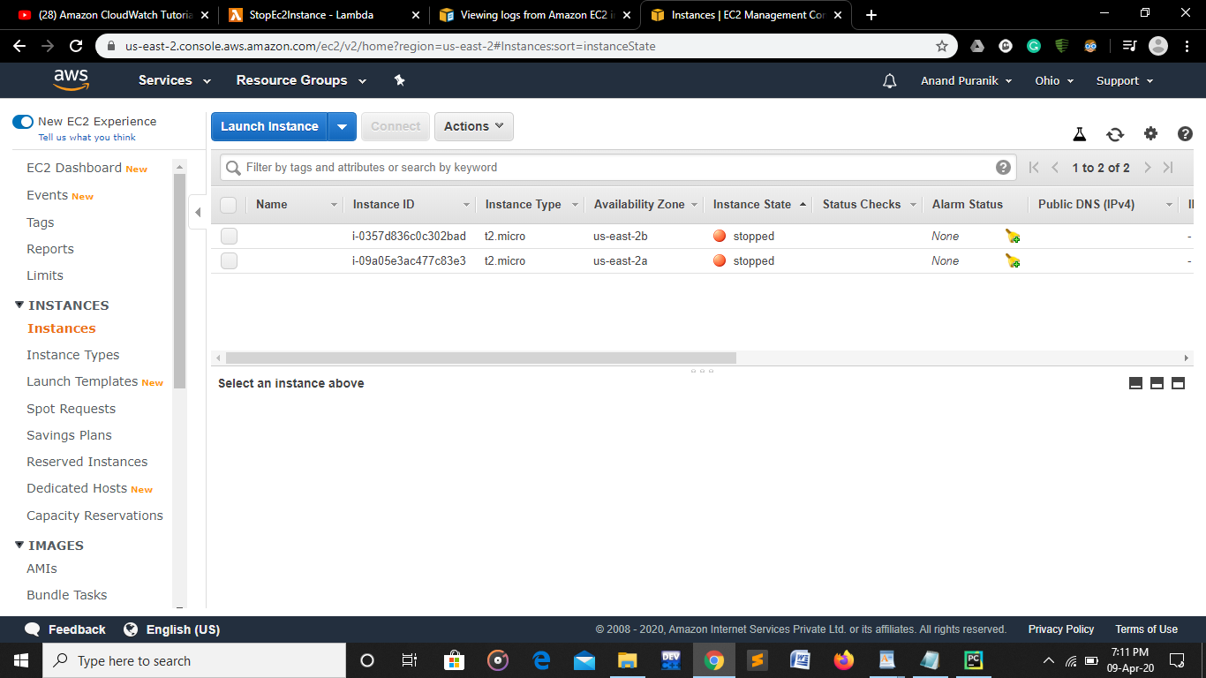

**Code to start:**

import boto3  
region = 'us-east-2'  
instances = ['i-0357d836c0c302bad']  
ec2 = boto3.client('ec2', region_name=region)  
  
def lambda_handler(event, context):  
    ec2.start_instances(InstanceIds=instances)  
    print('started your instances: ' + str(instances))

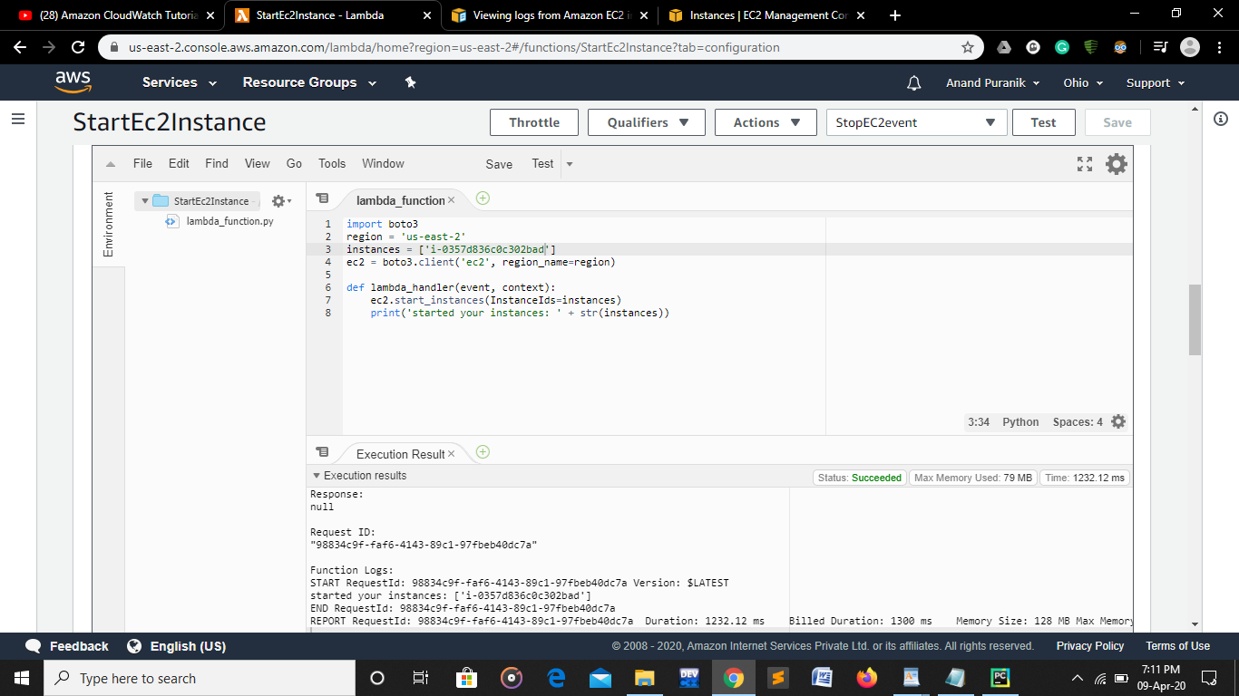

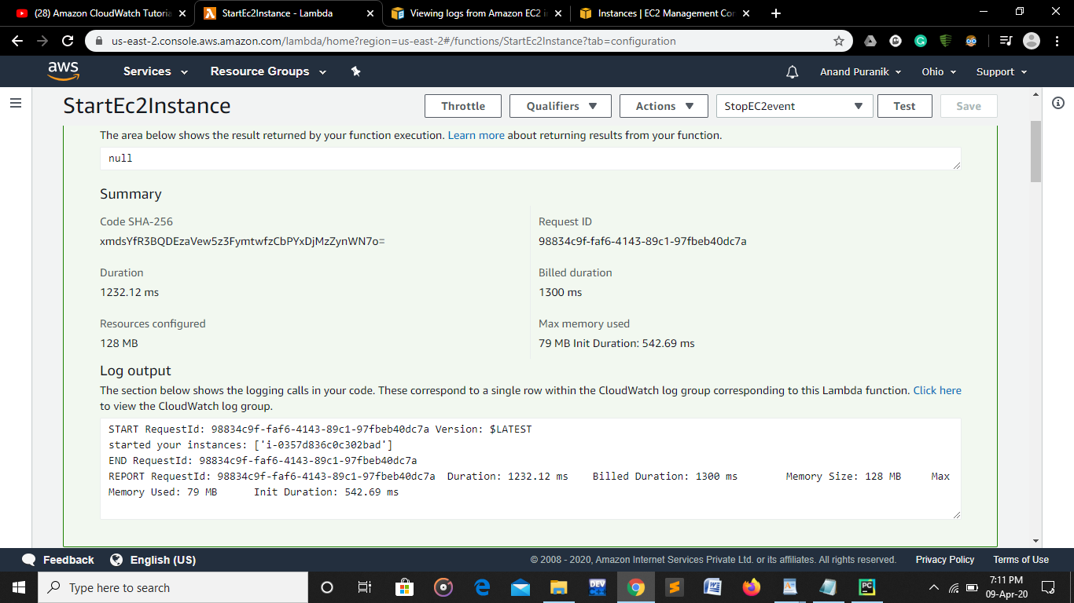

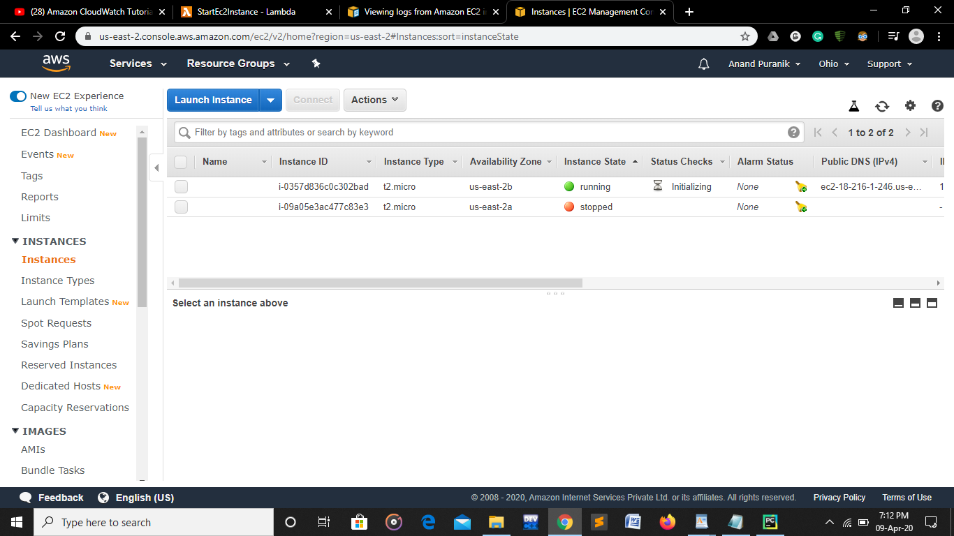

**Create a lambda function to send an email notification to your email id of your AWS account, as soon as you delete a file from an S3 bucket, mentioning the file name which is deleted.**

* Create a lambda function with following policies attatched to it:

1. AmazonSESFULLACCESS
2. AWSLambdaExecute

* Choose a bucket -> Go to Properties -> Advance settings and choose Events

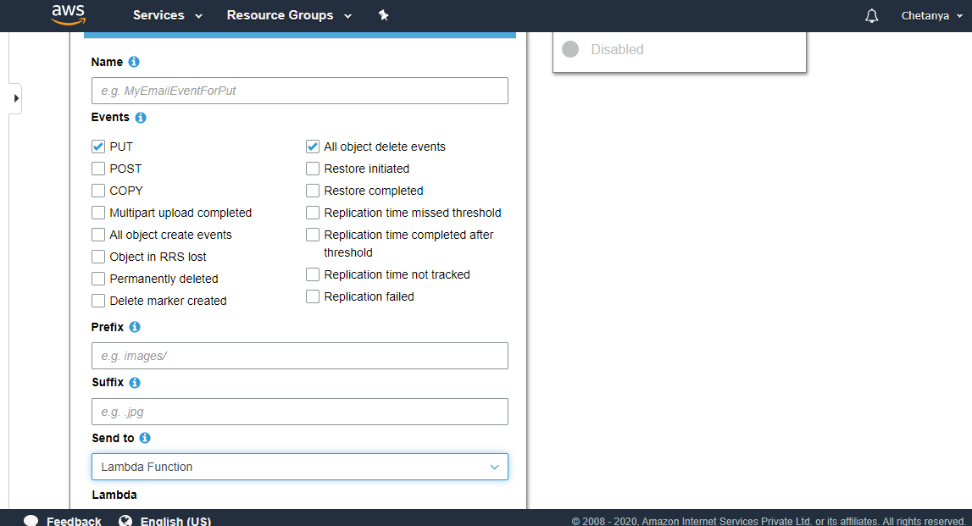

* Select PUT and all object delete events as shown above
* Select Lambda Function as an option in send to box
* Move to lambda function and write the code given below to send notifications on deletion in your s3 bucket
* Code:

import json  
import boto3  
  
def lambda_handler(event, context):  
     
   for i in event["Records"]:  
    action = i["eventName"]  
ip = i["requestParameters"]["sourceIPAddress"]  
bucket_name = i["s3"]["bucket"]["name"]  
object = i["s3"]["object"]["key"]  
  
client = boto3.client("ses")  
  
subject = str(action) + 'Event from'  +  bucket_name  
body =  """  
<br>  
This is email is to notify you regarding {} event.  
Source IP: {}  
""".format(action, ip)  
  
message = {"Subject": {"Data": subject}, "Body":{"Html" :{"Data": body}}}  
  
response = client.send_email(Source= "c.nagpal11@gmail.com",Destination = {"ToAddresses":["c.nagpal11@gmail.com"]}, Message= message)  
  
     
    # TODO implement  
    return {  
        'statusCode': 200,  
        'body': json.dumps('Hello from Lambda!')  
    }

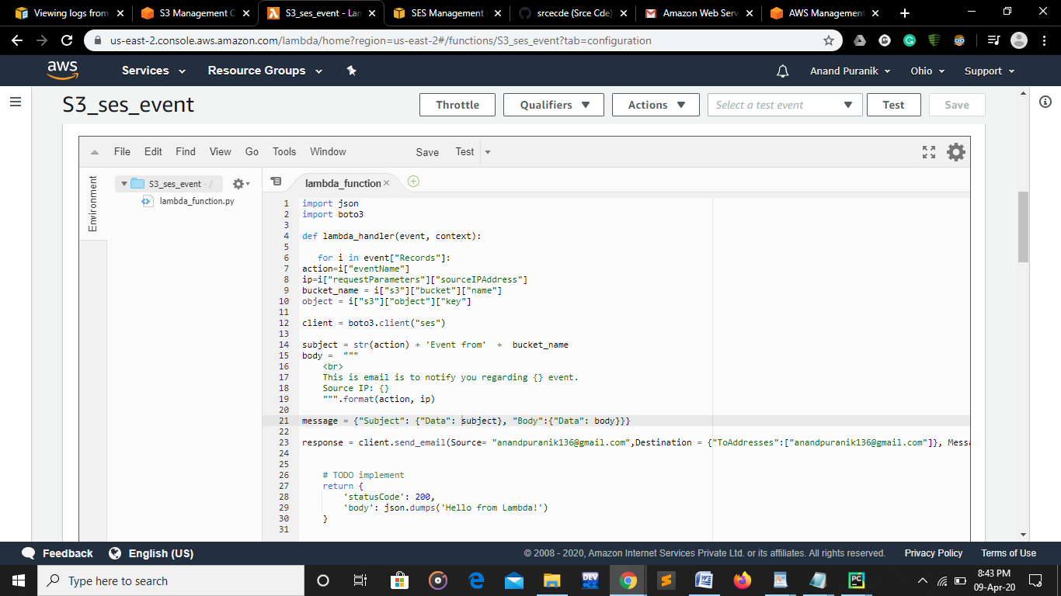

**CONCLUSION: After successful execution of your code you will start receiving email notifications on deletion of files in s3 bucket after verifying your email id.**